**Motion Control Cursor For Assistive Technology**

**Introduction**

An air mouse, also known as a motion-sensing mouse, is a pointing device that uses motion sensors to control the movement of the cursor on a computer screen. It allows the user to control their computer from a distance, without needing to be in close proximity to their computer.

There are several reasons why someone might want to use an air mouse:

**Convenience**: An air mouse is very convenient to use, especially if you are using a computer that is located far away or in a hard-to-reach spot. With an air mouse, you can control your computer from a comfortable distance, without having to move closer to it.

**Ergonomics**: Using an air mouse can be more comfortable and ergonomic than using a traditional mouse. This is because you can hold the air mouse in a way that is comfortable for you, without having to worry about the placement of your hand or wrist.

**Presentations:** An air mouse is ideal for presentations or demonstrations, as it allows the user to control the computer and the presentation from a distance. This can be especially helpful if you are presenting in a large room or if you are presenting to a group of people.

**Gaming:** Air mice can be useful for gaming, especially for games that require precise movements. With an air mouse, you can move the cursor with greater precision than with a traditional mouse, which can be helpful in games that require a high degree of accuracy.

Overall, an air mouse can be a very useful tool for those who need to control their computer from a distance or who are looking for a more ergonomic way to use their computer.

**Methodology**

Step1: Gather information after reviving research papers.

Step2: Decide the Final design.

Step3: Collect Hardware components.

Step4: Circuit implementation

**Literature review:**

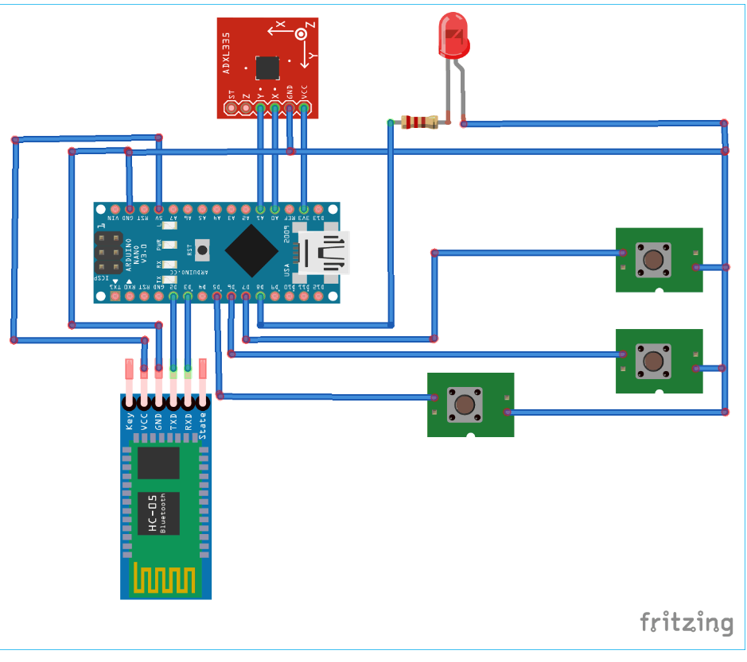

**Hardware components:**

1. **Raspberry pi**
2. **Bluetooth module**
3. **MUP 6050**
4. **Push buttons**
5. **Resistor LED**
6. **USB to TTL convertor**

**Raspberry Pi**

It is based on the ARM architecture and is designed to be used for a wide range of projects, from basic computer programming to robotics and Internet of Things (IoT) applications.

While microcontrollers are typically used for simpler tasks and have limited processing power and memory, the Raspberry Pi is a more powerful computing device that can run a full operating system and support a wide range of programming languages and software.The Raspberry Pi has a number of different models available, each with its own specifications and capabilities. However, all models feature a CPU based on the ARM architecture, as well as GPIO (General Purpose Input/Output) pins that can be used to connect to external devices and sensors.Overall, the Raspberry Pi is a versatile and affordable tool that has become increasingly popular in the maker and DIY communities, as well as in education and research.

**MPU 6050**

The MPU 6050 is a commonly used integrated circuit (IC) that combines a 3-axis accelerometer and a 3-axis gyroscope. It also includes an on-board temperature sensor and supports digital input/output interfaces, making it useful for a wide range of applications, such as motion tracking, robotics, and gaming.

The accelerometer measures the acceleration of the device in three perpendicular axes, while the gyroscope measures the rotational movement around those same axes. By combining these

measurements, the MPU 6050 can provide accurate information about the orientation and movement of the device.

The MPU 6050 can communicate with a microcontroller using a variety of interfaces, such as I2C or SPI, and it can be programmed to provide various types of data outputs, such as raw sensor data or filtered values. It also includes built-in algorithms for motion detection and gesture recognition, which can be used to detect specific movements or gestures.

Overall, the MPU 6050 is a versatile and widely used IC that provides a range of motion sensing capabilities, making it useful for a wide range of applications in various fields, including robotics, gaming, and motion tracking.

**Bluetooth Module HC – 05**

The HC-05 is a Bluetooth module that can be used to enable wireless communication between electronic devices. It is based on the Bluetooth 2.0 standard and can operate in both master and slave modes, allowing it to connect to other Bluetooth devices such as smartphones, tablets, or computers.

The HC-05 module is relatively easy to use and configure, and it can be interfaced with microcontrollers such as Arduino or Raspberry Pi through its serial interface. It has a range of up to 10 meters and supports a variety of data rates, from 9600 to 115200 bps.

The HC-05 module has several different pins that can be used for power supply, ground, and serial communication. It also has an onboard LED that indicates the status of the module, such as when it is in pairing mode or connected to another device.

Overall, the HC-05 is a versatile and affordable Bluetooth module that can be used in a wide range of projects, from robotics and automation to home automation and wireless sensor networks.

**USB to TTL converter**

A USB to TTL module is a small electronic device that allows you to connect a computer or other USB-enabled device to a device that uses TTL (Transistor-Transistor Logic) level serial communication. TTL is a common type of communication used in electronics projects, and it typically operates at a voltage of 5V or 3.3V.

The USB to TTL module typically consists of a USB connector, a microcontroller or USB-to-serial converter chip, and a TTL-level serial port. It may also include additional features such as voltage regulation and level shifting circuitry to allow it to work with devices that use different voltage levels. To use a USB to TTL module, you typically connect it to your computer's USB port, and then connect the TTL-level serial port to your device's serial port. This allows you to communicate with the device using a terminal program or other software. USB to TTL modules are commonly used in electronics projects for programming microcontrollers, communicating with sensors and other devices, and for general-purpose serial communication. They are relatively inexpensive and widely available from electronics suppliers.

**Flow Chart**



